4.6.1 Triple Integrals in Cylindrical Coordinates Worksheet

- Change the following points from rectangular coordinates to cylindrical coordinates.

- (round your angle measurement to 2 decimal places)

- Describe in words the surface who equation is given.

- For each of the given integrals, label the box below the picture of the corresponding region of integration in cylindrical coordinates.
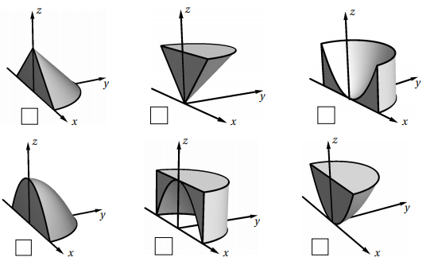

- Sketch the solid whose volume is given by the integral and then evaluate the integral.

- Evaluate , where E is enclosed by the paraboloid and the plane .

- Evaluate , where E is the solid in the first octant that lies under the paraboloid .

- Evaluate , where E is enclosed by the planes and and by the cylinders and .

- Find the volume of the solid that lies between the paraboloid and the sphere .

- Evaluate the integral by changing to cylindrical coordinates.

We see that the region of integration is given by:

- Let E be the solid region bounded by the ellipsoid . Let . In the following parts we will try to using cylindrical coordinates.
- Set up the integral using cylindrical coordinates without bounds first and try to determine which order your differentials should be in to make your integration as easy as possible.

- Fully setup up your integral with bounds.

- Calculate the integral you found in (b). Hint: After integration with respect to r consider using properties of logarithms to help simplify.

